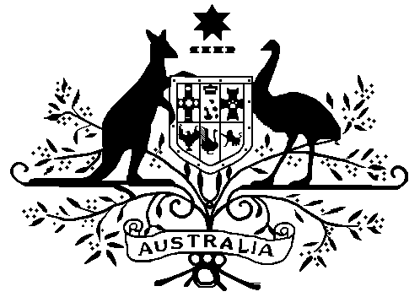

High Court of Australia

Party Category Information
Under the High Court of Australia (Fees) Regulations 2022, different rates apply for filing and hearing fees depending on whether the party liable to pay that fee is:
- a publicly listed company – which pays the highest rate of fees;
- a corporation or a public authority – which pays the next highest rate;
- an individual, a small business, a not-for-profit association, or any other case – which pays the lowest rate.
If a party is made up of different bodies or persons, then the highest rate of fee which can apply is payable.

Party Category Information Definitions

Publicly listed company
A company listed on a stock exchange or financial market in any country.

Corporation
Includes:
- a company;
- a body corporate;
- an unincorporated body that, under the law of the place where the body is formed, may:
  - sue or be sued; or
  - hold property in the name of the secretary of the body or an office holder of the body appointed for that purpose;
- a public authority (see “Public authority” below);
- a corporation registered under the Corporations (Aboriginal and Torres Strait Islander) Act 2006;
- a trade union.

But does not include:
- a corporation sole that is not a public authority;
- a small business (see “Small business” below);
- an unincorporated not-for-profit association (see “Not-for-profit association” below).

Public authority
Means:
- a body or authority of the Commonwealth or a State or Territory, including:
  - a Department of the Commonwealth or a State or Territory;
  - a Department of the Parliament established under the Parliamentary Service Act 1999, a Department of the Parliament of a State or a Department of the legislature of a Territory;
  - any other non-corporate Commonwealth entity within the meaning of the Public Governance, Performance and Accountability Act 2013;
- a person representing a body or authority of the Commonwealth or of a State or Territory;
- a Minister for the Commonwealth or for a State or Territory;
- a statutory office holder.

Small business
Means a business with:
- no more than 19 employees; and
- a total turnover of less than $2 million each year.

Not-for-profit association
Means a society, club, institution, or body that is not formed for the purpose of trading or securing pecuniary profit from its transactions for its members.

Other
Any party other than a publicly listed company or corporation (including a public authority). It includes a small business and a not-for-profit association. It also includes an individual (i.e. a natural person).

